Prophet - Seasonality Mode: Additive - Fourier_order = 5

Date | Actual | Forecast | Diff

2023-07-01 | 10042.0 | 11281.62 | 1239.62

2023-08-01 | 11566.0 |  | 11670.38 | 104.38

2023-09-01 | 11759.0 | 11784.52 | 25.52

2023-10-01 | 11890.0 | 9662.71 | 2227.29

2023-11-01 | 11770.0 | 10099.30 | 1670.70

2023-12-01 | 18289.0 | 14158.20 | 4130.80

Mean Absolute Error for Prophet: 1566.39
Mean Squared Error for Prophet: 4393962.01
Root Mean Squared Error for Prophet: 2096.18
Mean Absolute Percentage Error (MAPE) for Prophet: 0.11%

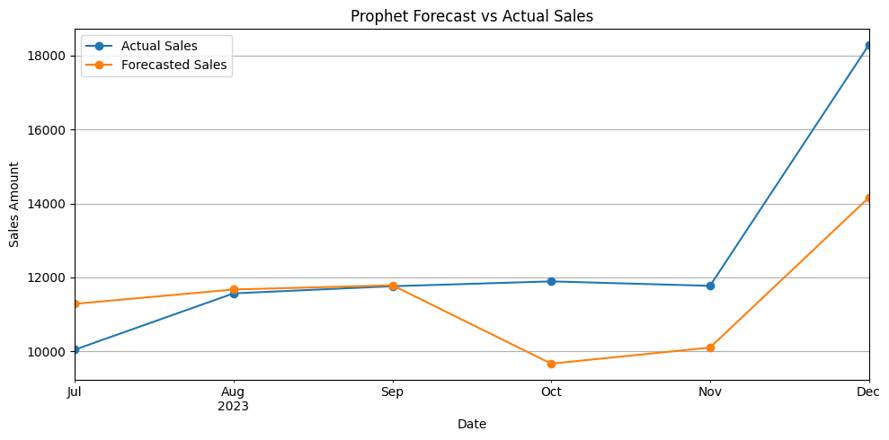

ChatGPT signed out | ChatGPT signed in
Critical Evaluation of Prophet's Forecast  - ✅ General Performance:  Prophet performed reasonably well in July–September but struggled in Q4 (Oct–Dec), especially December.  - 📉 Biggest Miss – December:  Prophet underpredicted December by over 4,100 units, despite your holiday effect. This suggests the holiday bump was underestimated, or the model couldn’t learn enough from limited training data.  - ⚠️ Overfitting or Underfitting Q4?  The sudden dip in October and November forecasts (9662 and 10099) indicates Prophet might be overfitting to previous lower months or not capturing yearly seasonal resurgence well.  - 📦 Holidays + Regressors:  Even though you added HolidayMonth and Promotion as regressors, Prophet doesn't always weigh them heavily unless their signal is strong and consistent. You may want to engineer lag features or use more historical data.  - 🧠 MAPE Interpretation:  - MAPE is ~11%, which is moderate.  - But this average hides the fact that December alone introduces a large forecast error, which can distort downstream decisions like inventory planning. | Interpretation of Model Behavior  - July to September: Prophet is very close to actuals — deviations within 300–400 units.  - October to December: Large divergence begins — up to 4,000+ units underprediction in December.  - Prophet likely misestimated seasonal amplitude or undermodeled promotional impact.  3. Underfitting / Overfitting Considerations  - MAPE = 11% seems acceptable on average, but error variance is too high (spikes in RMSE).  - Prophet likely underfit seasonality dynamics due to small dataset (48 months), as it learns trend + seasonality as additive components.  - Since promotions were binary and rare, Prophet likely couldn't weight them correctly across months like December.  🧠 Critical Thinking & Real-World Implications  ✅ Strengths:  - Prophet works decently during regular months (July–September) → business as usual forecasting is decent.  - Highly interpretable framework, good for communicating results to business teams.  ❌ Weaknesses:  - Fails badly when demand surges sharply — underpredicts December by over 4,000 units.  - Prophet doesn’t explicitly model autocorrelation, so lags of prior months are not considered unless manually engineered (SARIMA does this better).  - Holiday and promotion effects need more robust feature engineering and longer data history to matter.  🔭 Way Forward
  Recommendation | Action
  Add changepoints | Prophet supports modeling abrupt changes in trend — worth tuning for November–December spikes.
  Engineer lag features externally | Add rolling averages or lags as new regressors — Prophet doesn't do this natively.
  Try multiplicative seasonality | Your sales spikes are strong — try changing seasonality_mode to 'multiplicative'.
  Run Prophet with more Fourier terms | fourier_order=5 may be too low to capture sharp seasonality (try 8–10).
  Blend SARIMA + Prophet | Consider hybrid models or ensemble — SARIMA captured seasonality better, Prophet captured smooth trends.

